Basic Knots etc

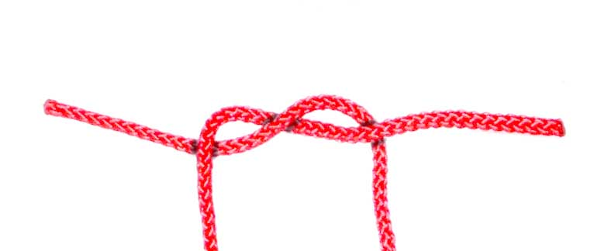
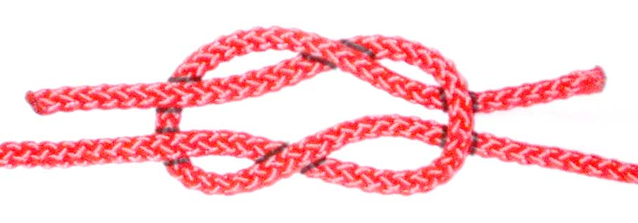
Overhand Knot and Reef Knot

1 - Overhand Knot: Left over Right then Under 2 - Reef Knot - Right Over Left then Under.
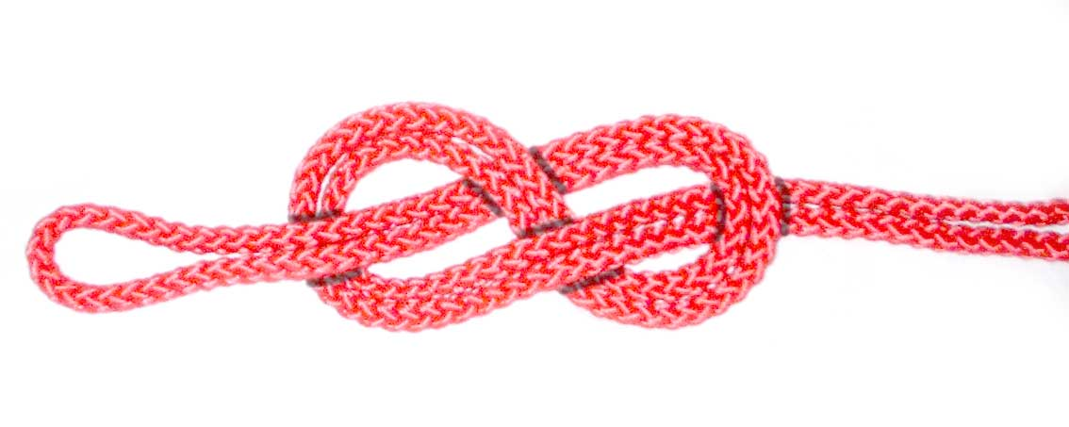

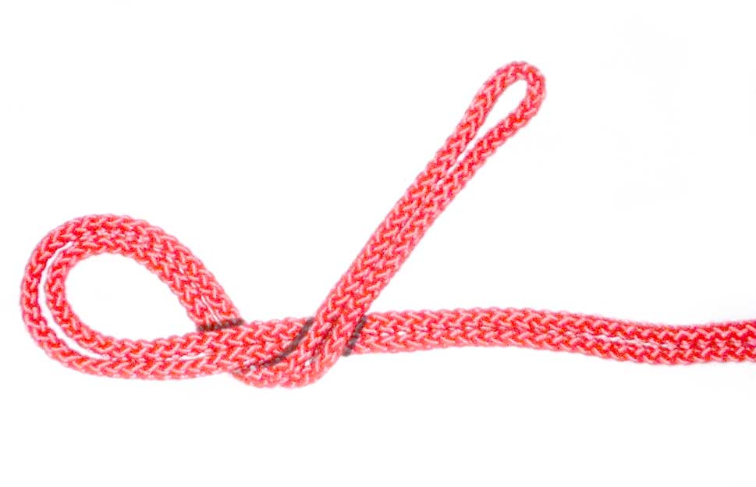
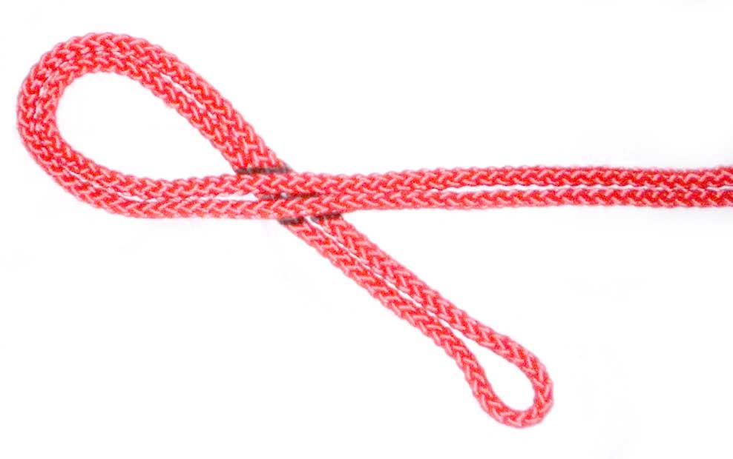Figure 8 Knot

1 - Loop the centre of the rope 2 - Bring the centre of the rope 3 - Take the centre of the rope
under the tails over the tails under and through the loop.
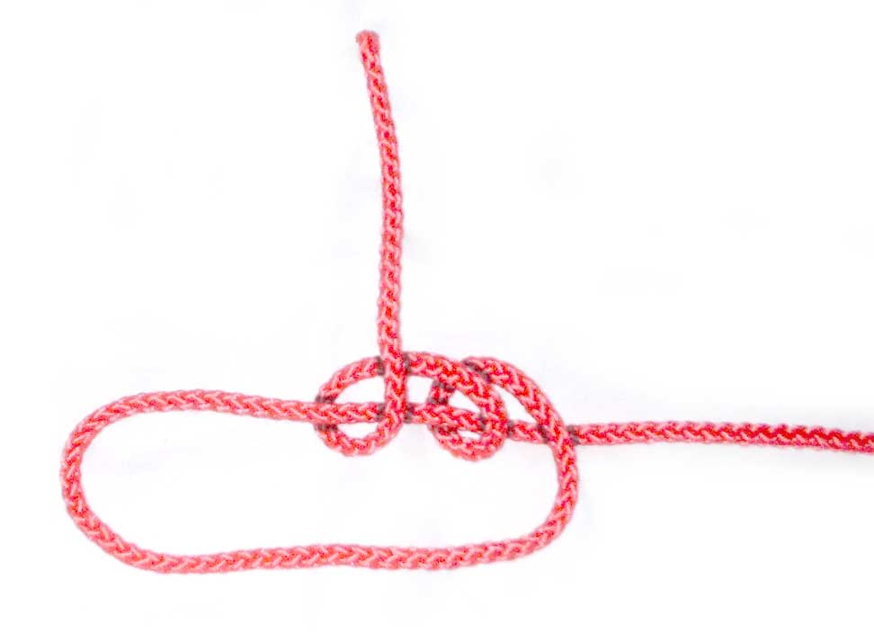

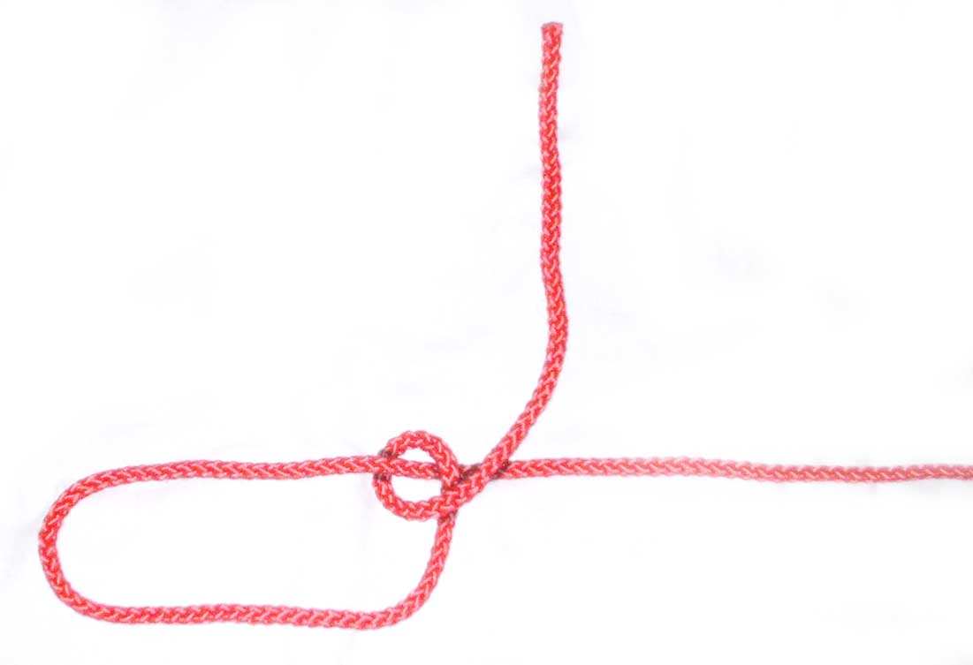
Taut Line Hitch
1 - Taut Line Hitch - Make a loop in the rope 2 - Bring the tail under and over the
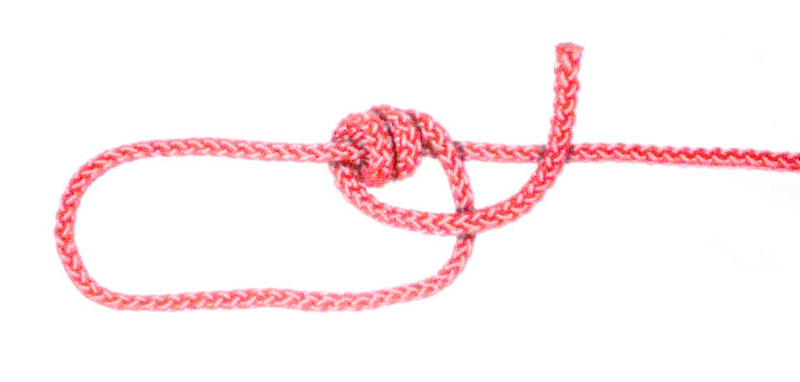
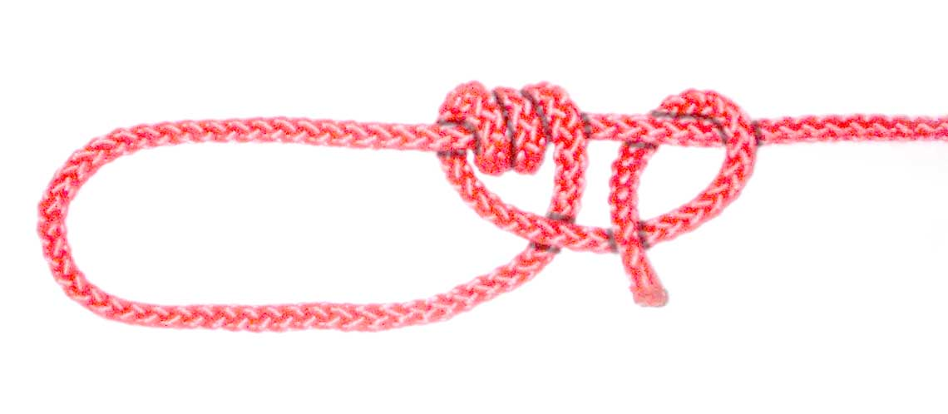
and take the tail over the main rope, then main rope towards the loop again
under towards the loop

3 - Draw the tail away from the loop and over 4 - Take the tail under the main rope
the main rope towards the loop and over itself

