Split Larks Head Cuff
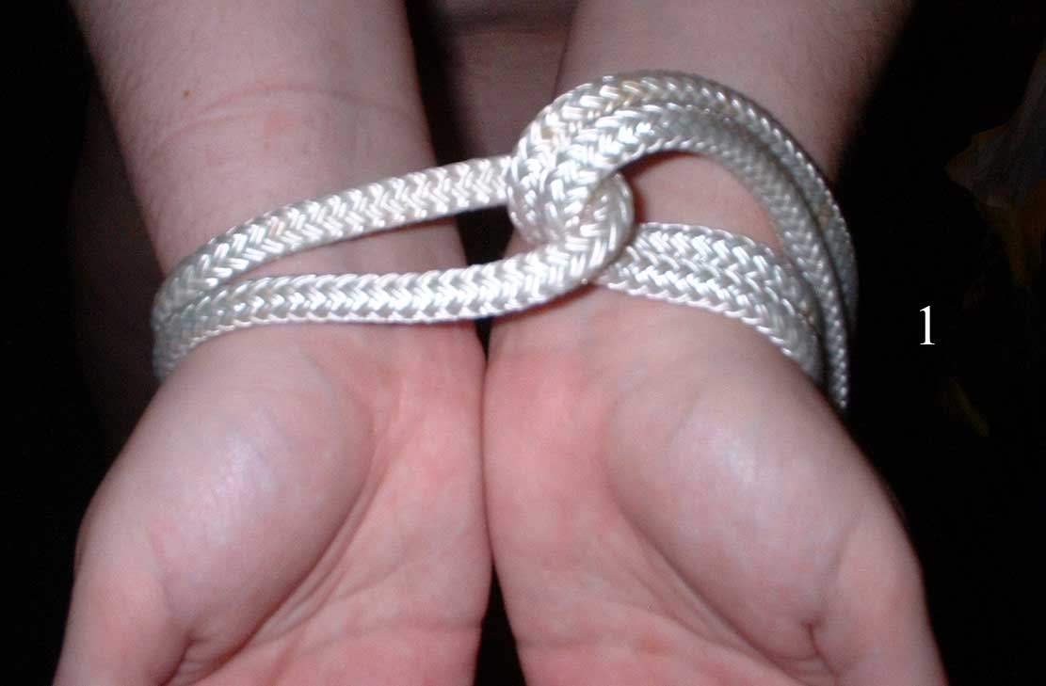
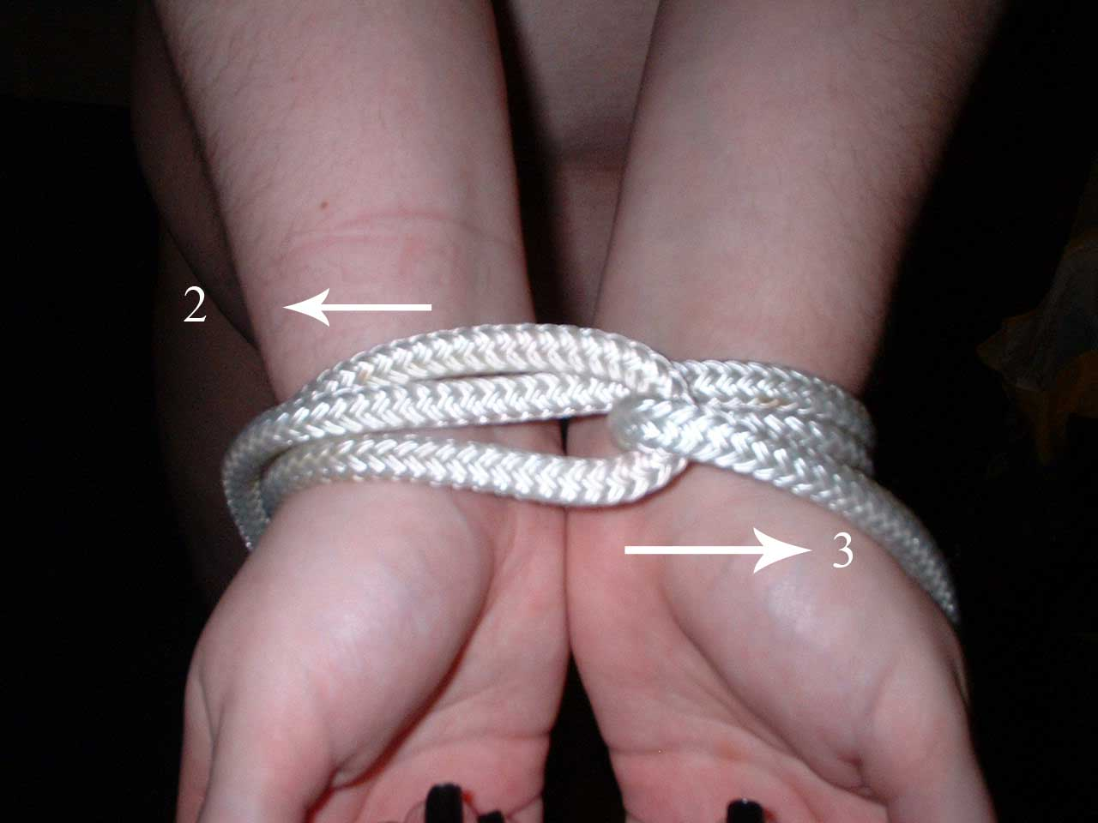

1 - Start with Larks Head Knot around both wrists 2 + 3 Wrap the tails in opposite directions around
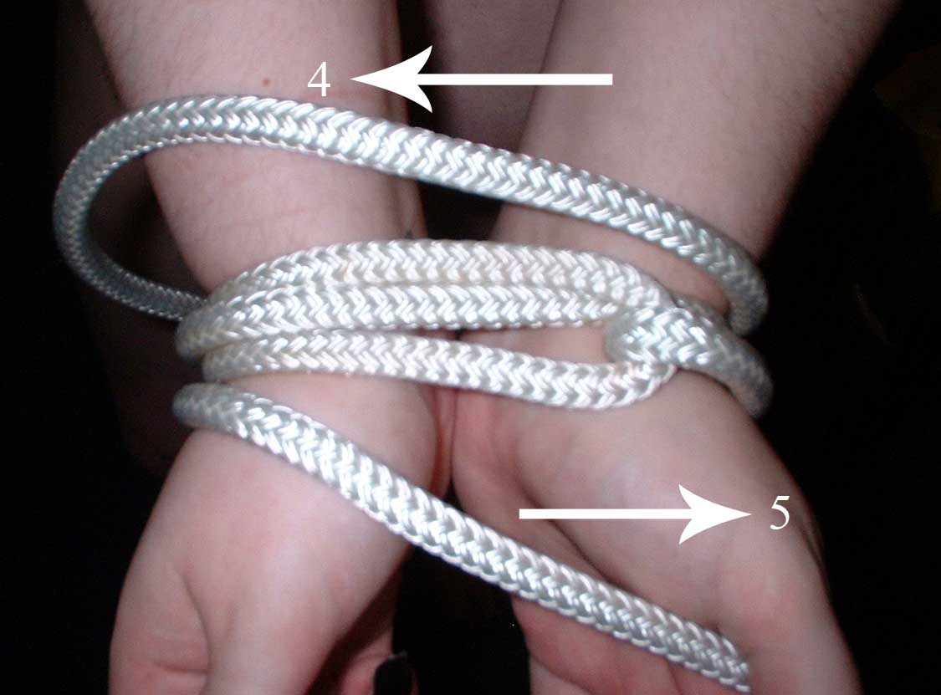
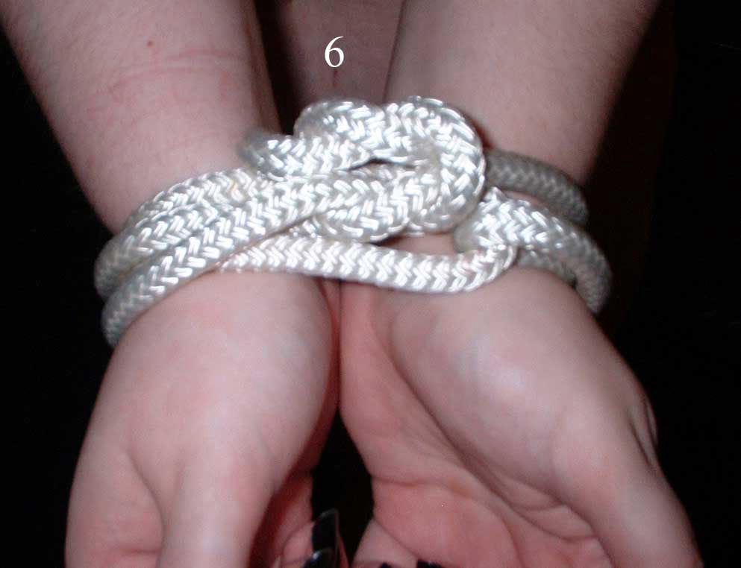 the wrists

4 + 5 Continue to wrap the tails around the wrists 6 Bring the tails together and tie off.
in opposite directions.

