The Cat's Paw Cuff
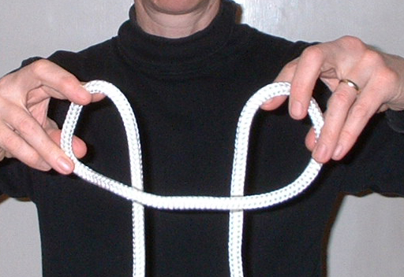
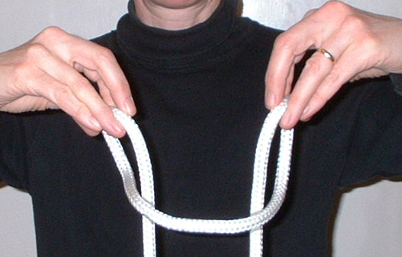

1) Hold the centre of the rope and twist both hands inwards as if starting a Larks Head knot.
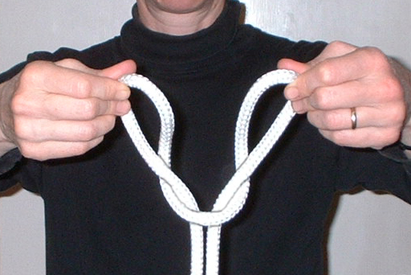
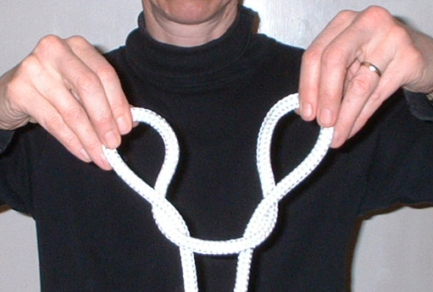
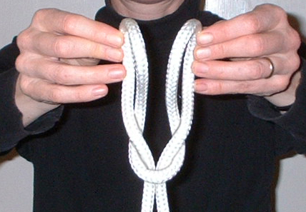
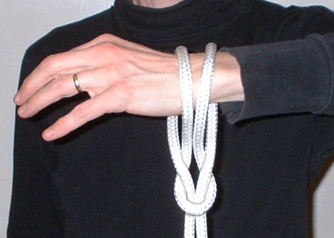
2) Continue to twist both hands so the loops have turned 360 degrees.

3) Keep twisting to bring the outsides of the loops into the centre.

