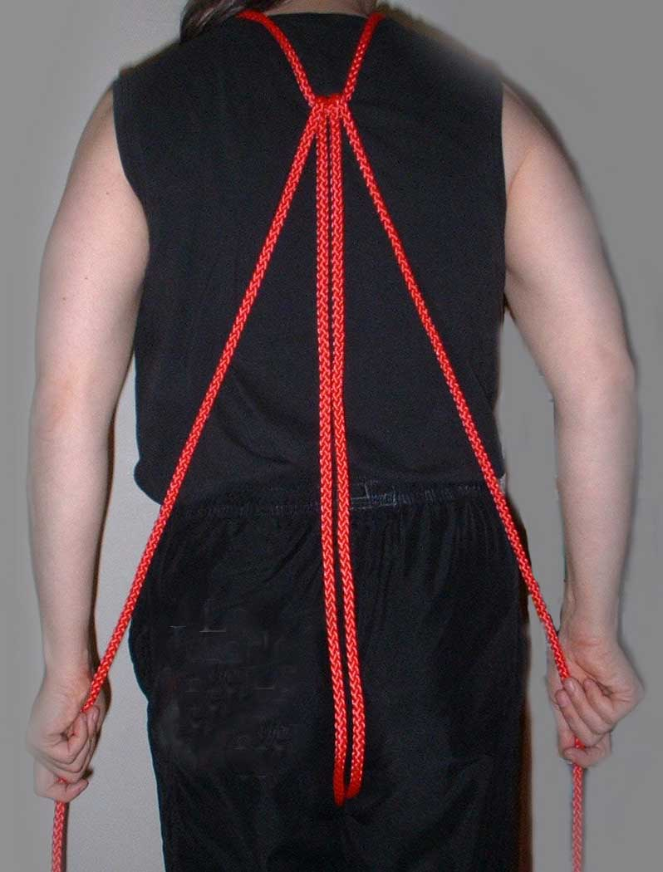
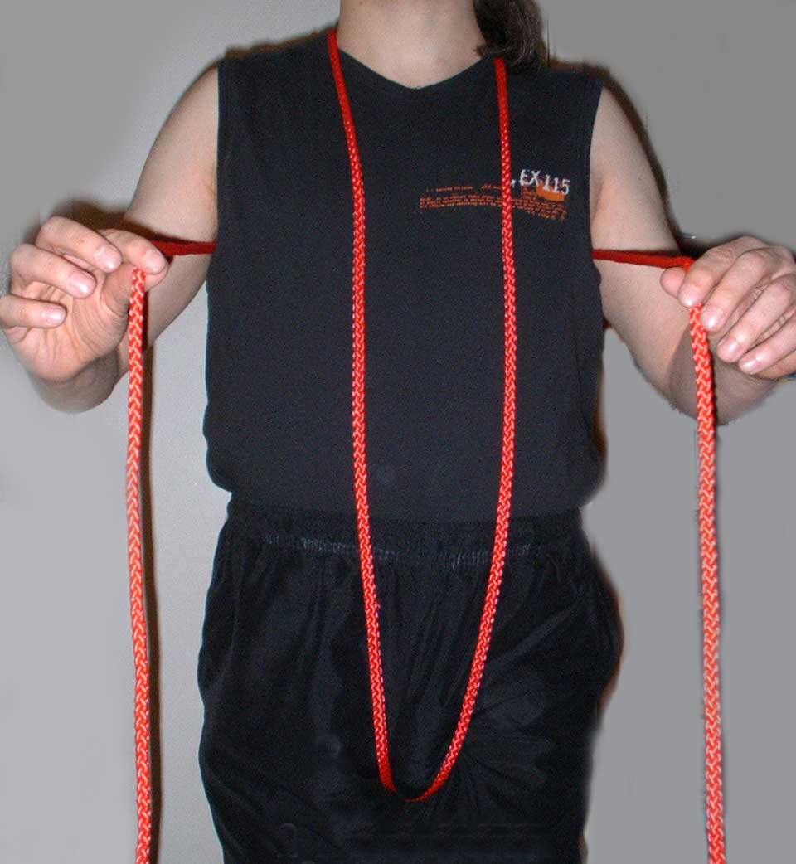
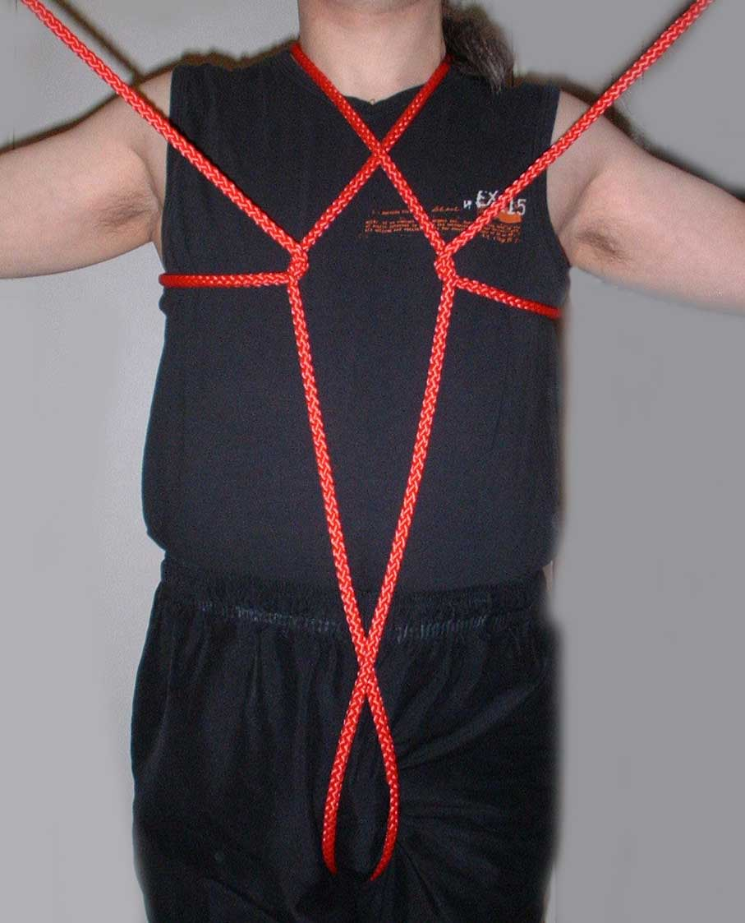
Tortoiseshell Harness (Un-knotted version)

1 - Start with Larks Head  Knot loosely  around body | 2 - Bring tails around  to the front of the body | 3 - Cross left tail under  right central rope and  vice versa

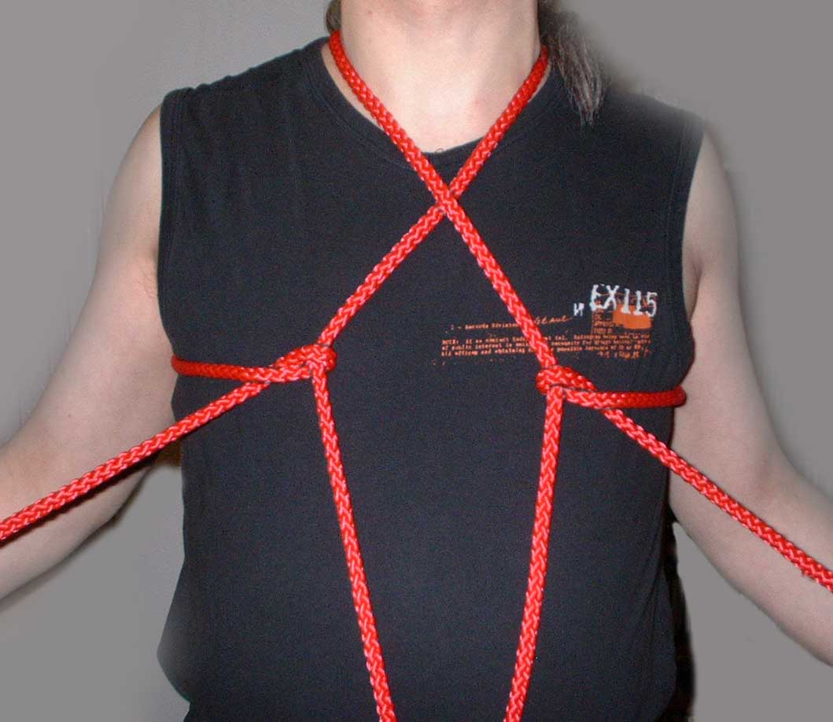
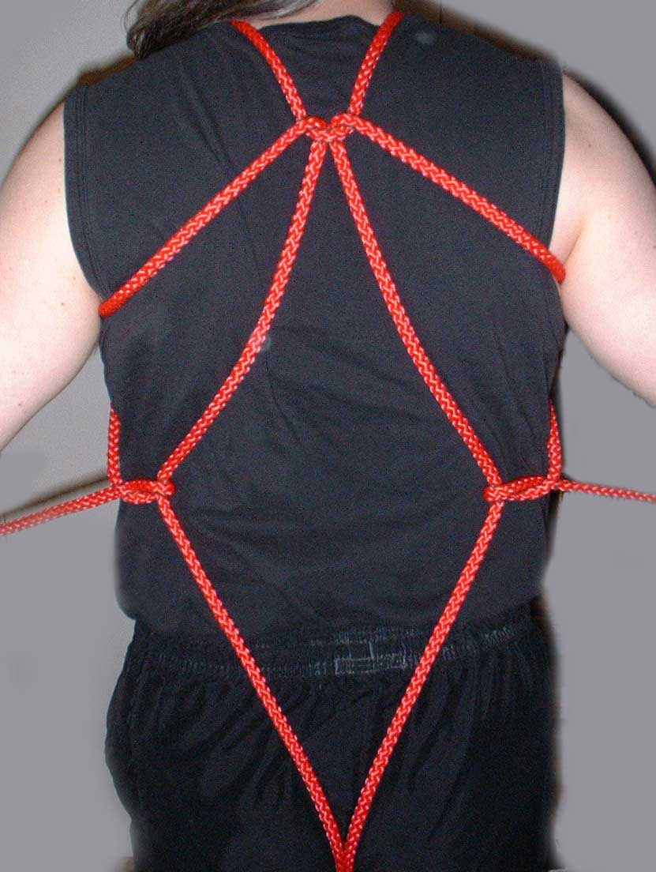
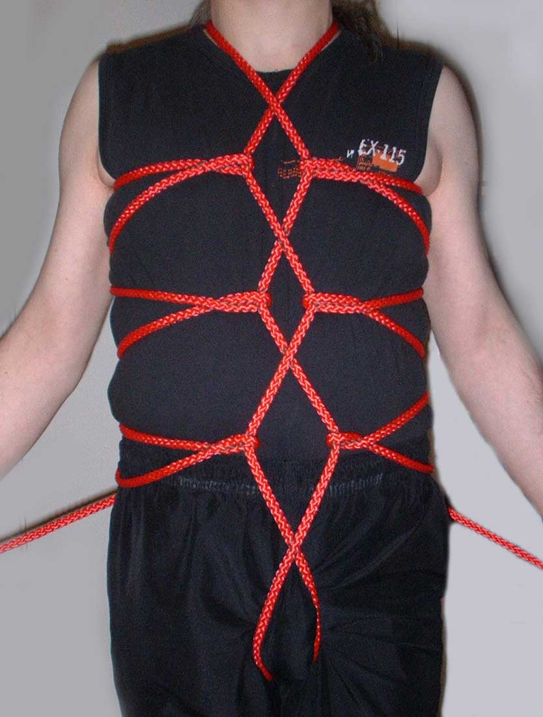

3 - Loop tail upwards over central  rope, then down and under itself | 4 - Repeat process  at back of harness | 5 - Repeat cross loops down body, front and back

